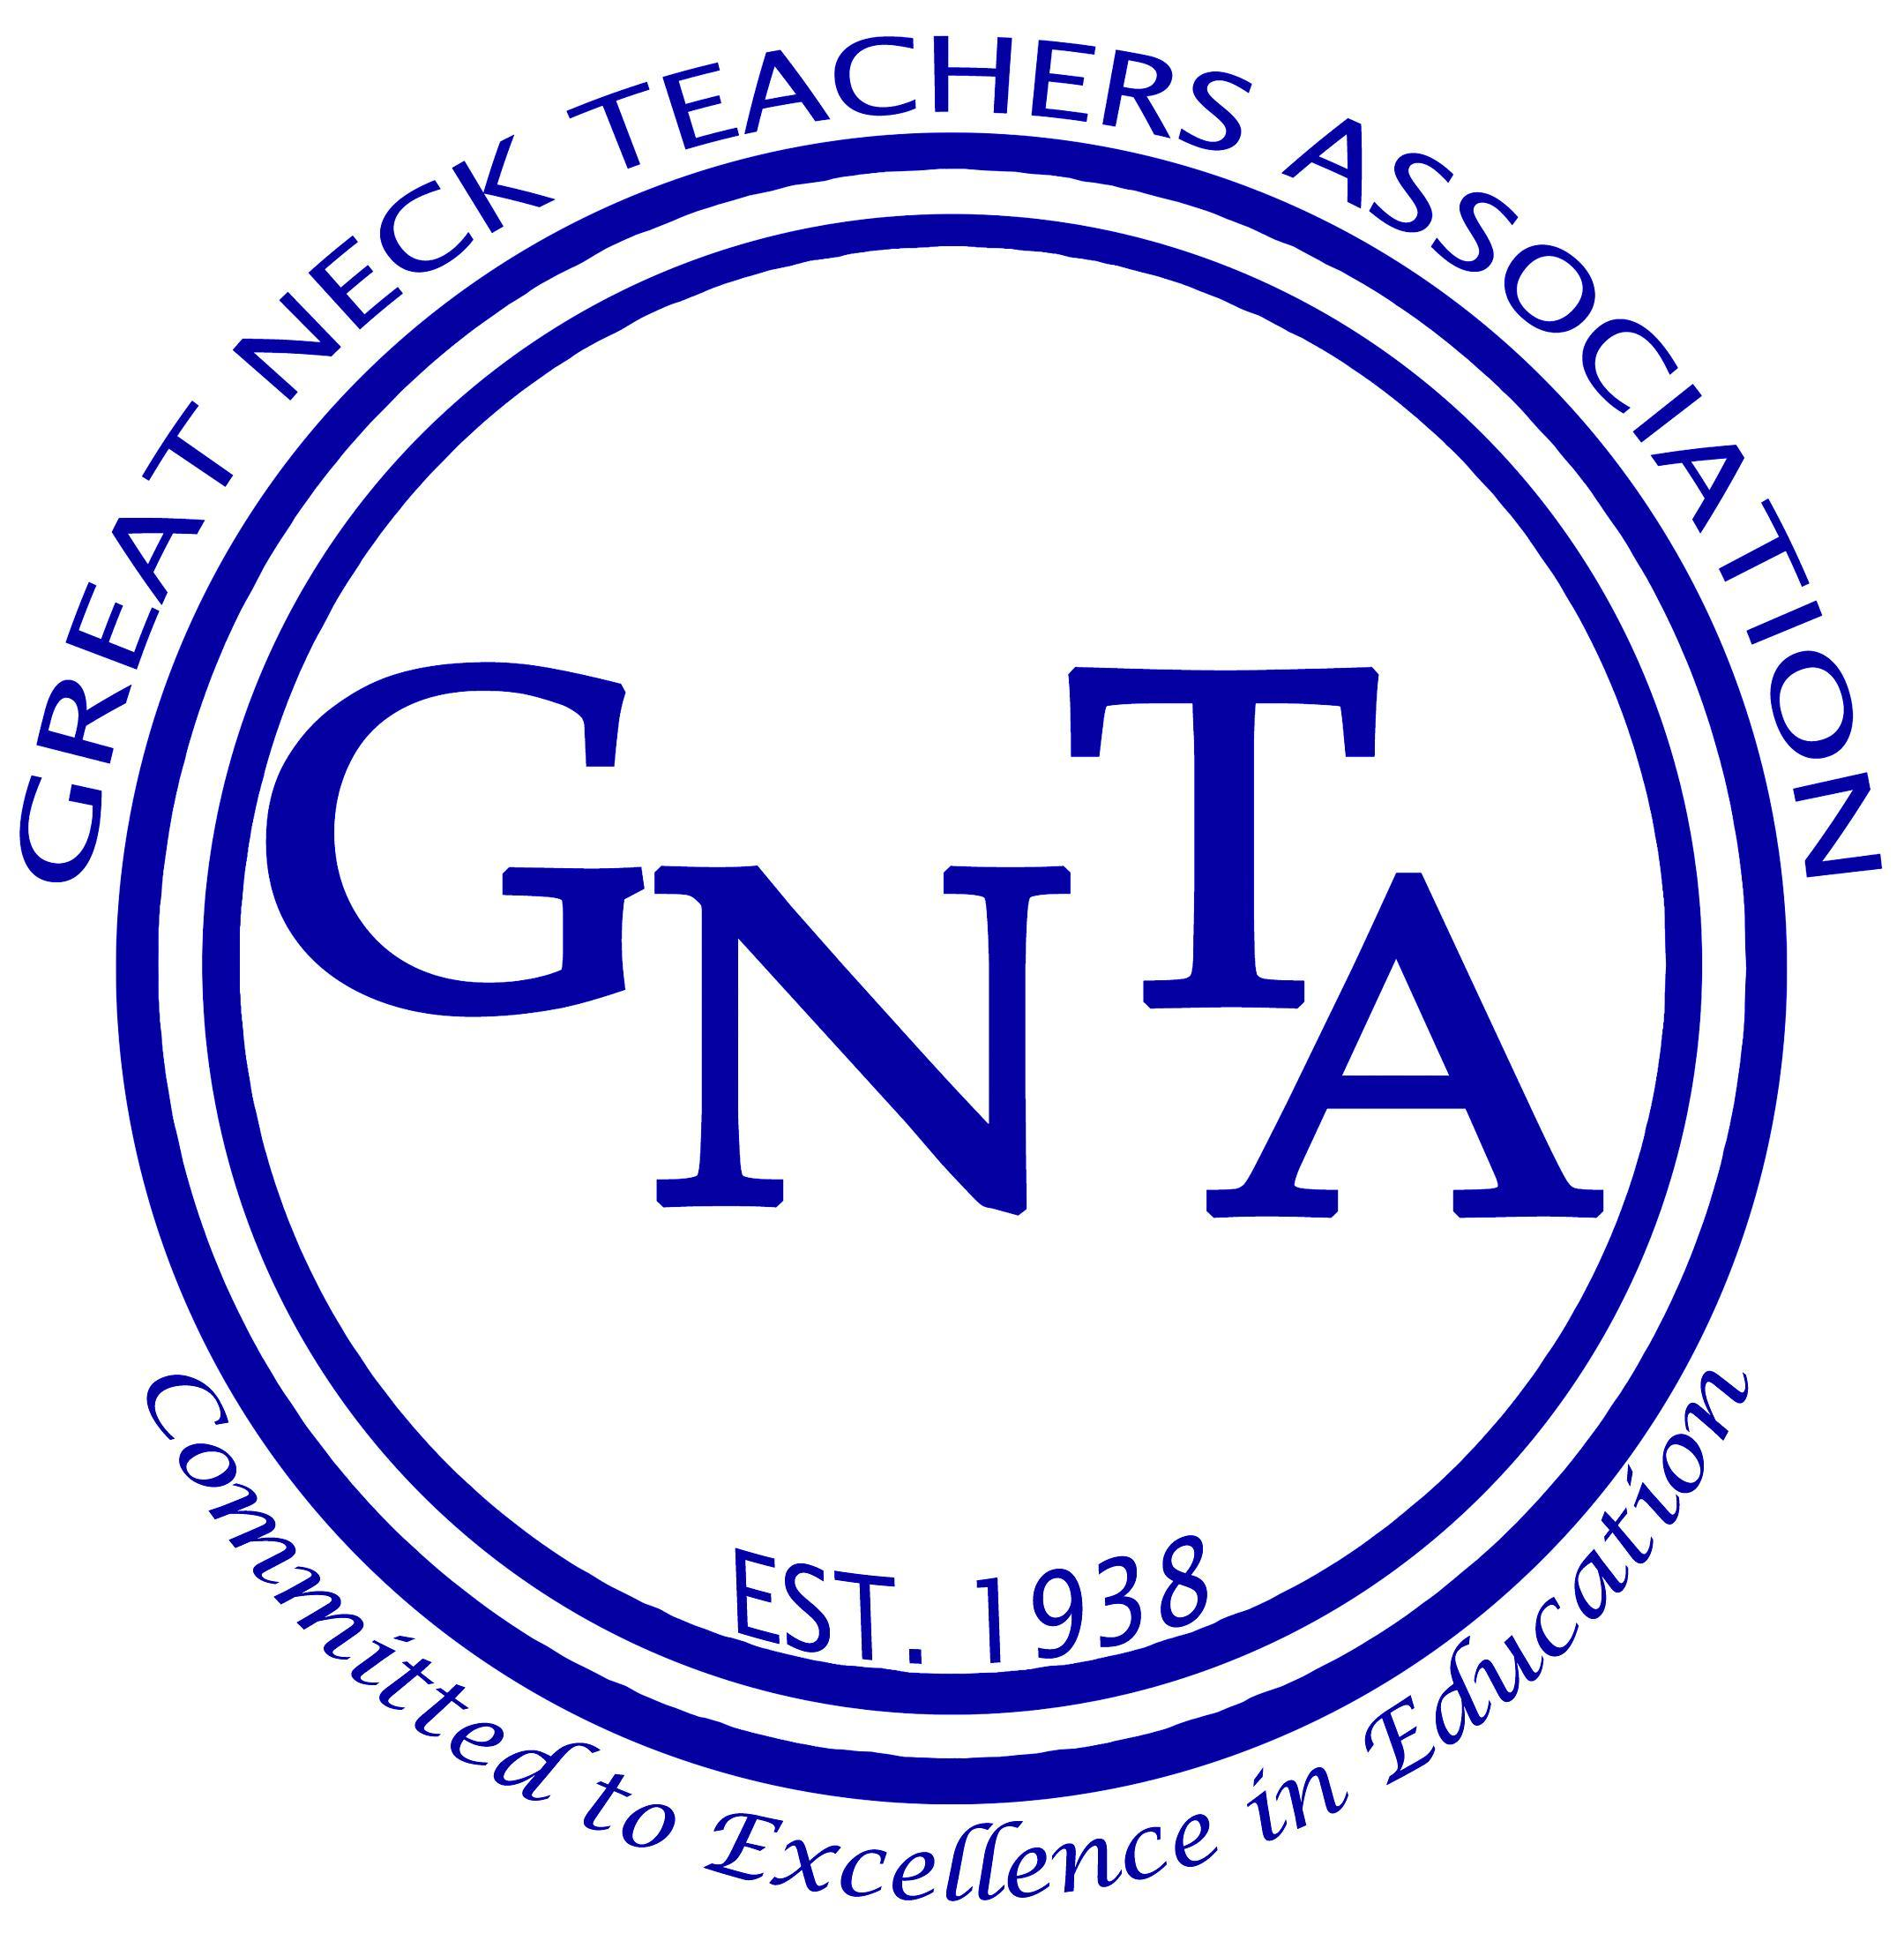

New Members Bulletin
Professional Development: What Teachers Need to Know
Volume 20, Number 2, 2018-2019
Teacher Learning That Supports Student Learning
Great Neck teachers have many opportunities for professional development both within and beyond the district. Many of these opportunities have been negotiated by GNTA and are therefore guaranteed by our contract. The Great Neck Teacher Center, the Inservice Institute, and the Technology Academy offer staff experiences to enhance professional knowledge and skills.
Staff members are entitled to request approval to attend professional conferences often at district expense. In addition, Summer Scholarship grants, that sometimes partially or completely fund graduate courses and general enrichment courses, are also available. Summer scholarship grants may not be used for administrative certification classes. Many of these professional development experiences culminate in the granting of credit toward salary advancement. We hope that the following articles will help encourage you to take advantage of these opportunities. For questions about professional development, contact Elaine Brendel: ebrendel@greatneck.k12.ny.us. For Summer Scholarship information, contact Kim Semder: ksemder@greatneck.k12.ny.us.

The Great Neck Teacher Center
The Great Neck Teacher Center offers a wide variety of professional development experiences to the teaching staff of the Great Neck Public Schools and to the teaching staff of the nonpublic schools located within the district. The mission of the Center is to meet the professional needs of staff members, and ultimately to enrich education for our students. The Center offers activities, programs, and services that inform, ignite, and inspire our staff and that complement and enhance the goals of our educational community. Our classes provide opportunities to earn Inservice credit and PD hours.
The Inservice Institute
The Inservice Institute is a unique district organization provided through the GNTA contract and funded by the Board of Education. Technology Academy merged into the Inservice Institute when government funding for this vibrant, valuable resource ended. The learning opportunities we provide in person or as a blend of in person and online can be applied to salary advancement, NYS Professional Development Hours requirements, and/or personal growth.
The committee includes representatives from the teachers, administrators, substitute teachers, office staff employees, and the superintendent's designees. The committee meets bi-monthly during the school year to discuss issues concerning inservice education. The Inservice Institute supports and encourages teachers and building experts to share skills and knowledge with peers. Many of our talented employees are pleased and eager to develop a theme, skill, or approach to share with peers and take on this compensated responsibility.
The committee looks for rigorous, targeted materials that will enhance teachers’ talents and build their repertoires. Intrabuilding classes address issues and needs unique to a single building; enrollment is limited to members of that specific faculty. All recommended classes are forwarded to the superintendent and the Board of Education for fund allocation. Approved courses are listed in MyLearningPlan catalogs; enrollees need only to push a button in order to enroll (or withdraw) from an activity.
A full technical description of the Inservice Institute, along with pertinent information for those seeking credit, can be found in our contract, Article 27.
The Technology Academy
Technology Academy courses are offered throughout the calendar year. They are taught by technology savvy Great Neck colleagues who are curriculum experts and have demonstrated leadership and expertise with a particular technology, application, website, or online resource. Course offerings and descriptions are proposed and then posted on the Internet through our professional development system, MyLearningPlan, where teachers can register online.
Professional Conferences
The agreement between the Great Neck Board of Education and the GNTA provides substantial money for faculty attendance at professional conferences. The rules governing conferences are covered in Article 13(D) of the GNTA contract. Briefly, conference attendance is administered by the BCG in each building. It recommends approval based on the perceived benefit to the district of the conference, as well as on the number of people applying for it. All conferences must be approved through MyLearning Plan.
Application should be made in advance, and you pay all costs yourself before the conference. You will be expected to write a summary of the conference, complete the appropriate expense forms, and submit these with your receipts. (See your BCG Chair for details.) You will then be reimbursed for all allowable expenses. The amount of money allotted for such conferences, and the fact that the decisions affecting conference attendance are participated in by the faculty through BCG, makes it another outstanding feature of our contract.
Summer Scholarships
The Great Neck Teachers Association contract provides funds for professional development for its members.
This sum is available for members to take courses to enhance their professional knowledge. Courses must be taken through an accredited school or professional organization. There must be some professional benefit derived by the teacher to justify funding for the course. Be on the lookout for a Summer Scholarship application, which must be submitted no later than April 25.
Since the amount of money available to the Summer Scholarship Committee is a set figure, the amount of the scholarship that you would receive may vary from year to year depending upon the number of teachers applying. The Summer Scholarship Committee attempts to fund first-time applicants at 100% of the cost of the course.
The Cottage
343 Lakeville Road
Great Neck, New York 11020
(516) 829-9070

GNTA Executive Board

Jim Daszenski, President
Jennifer Snyder, Vice President for Professional Rights & Responsibilities
Frank Bua, Vice President for Administration
Kim Semder, Vice President for Contract Improvement
Elaine Brendel, Vice President for Professional Development
Maxine Bazzani, Treasurer
Sandra Kaufman, Director, Elementary Grades PreK-2
Luci Legotti, Director, Elementary Grades 3-5
Jeffrey Bernstein, Director, High School
Dan Isaac, Director, Middle School

Kirsten Kuhn, New Members Coordinator and Bulletin Editor

GNTA is Online!
www.gnteachers.net

